GIT Notes:-

1. Git init command to initiate the git in your console
2. After adding file run command git add <file name >
3. Git commit <file name>

File now in local repo

To upload to remote like GitHub

4.1 remote add origin <https://github.com/chandramanigit/Jenkins_cicd.git> ( this https repo)

4.2 git remote set-url origin [git@github.com:chandramanigit/Jenkins_cicd.git](mailto:git@github.com:chandramanigit/Jenkins_cicd.git) ( use for SSH )

generate SSH key on your machine

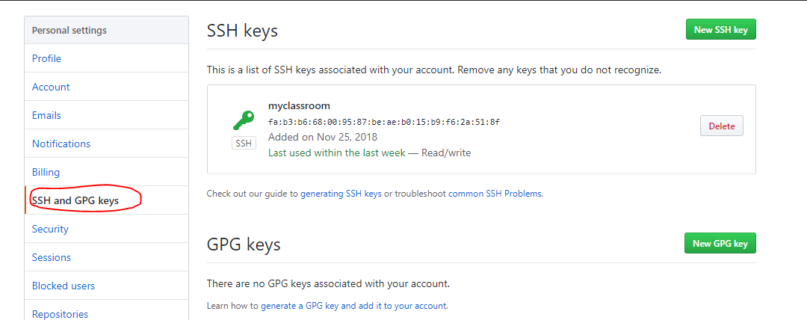

then add in GitHub

1. test using ssh [git@github.com](mailto:git@github.com)



